

*Fınal homework report*

prepared by

name surname : melih safa çelik

student number : 010180519

due date : 09/06/22

course name : spatıal analysıs and algorıthms ın gıs

course ınstructor: prof. dr. hande demirel

**Purpose of the Project**

It is wanted to finding best effective route for the distributions of flour by starting from the flour depot and visiting each stop such as restaurant, bakery and cafe, and return to the starting point which is flour depot. For this such, an appropriate network analysis should be done.

**Processing Steps**

At the beginning of the project, we have 3 data which are given previously. They are flour depot, roads and study area.

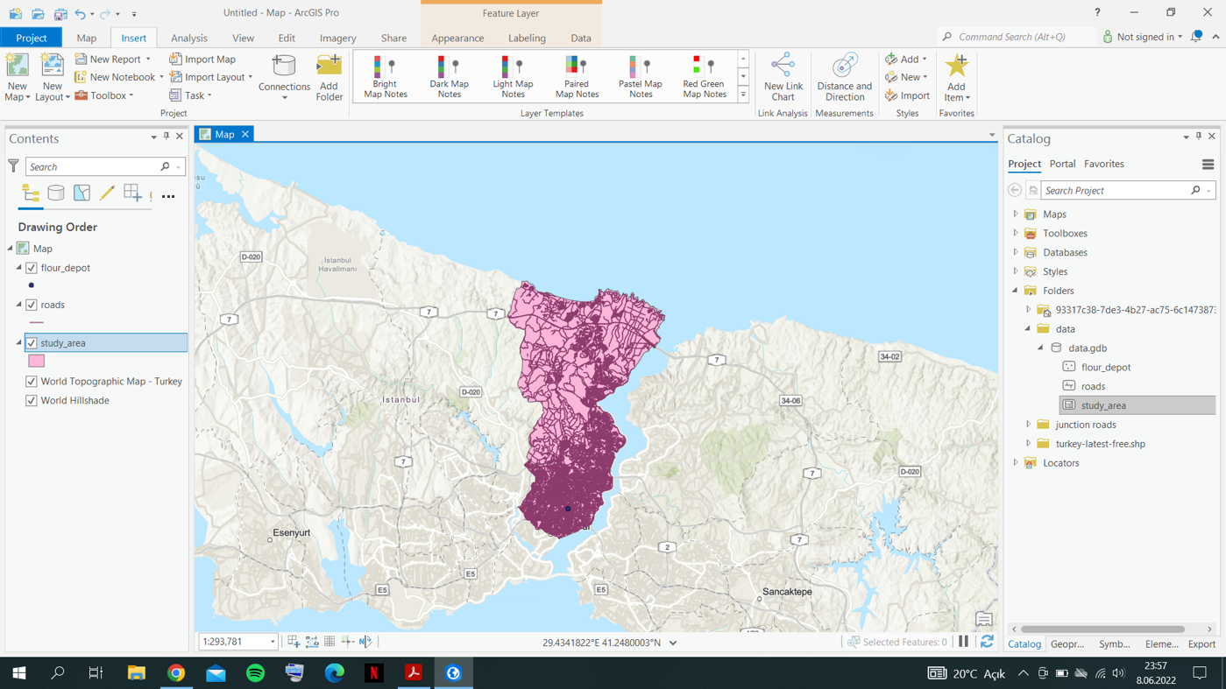

Furthermore, free and open source OpenStreetMap data are downloaded to find the stop points. These points are projected in WGS84 datum.

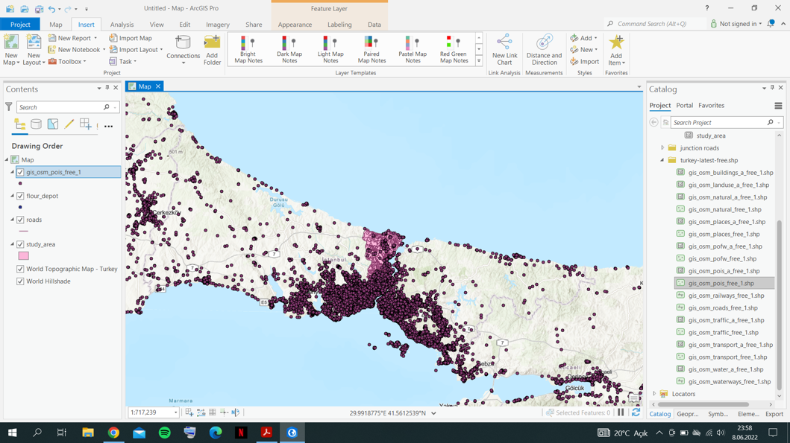

Since downloaded data are in WGS84 datum, they needed to be reprojected to the project datum format which is TUREF_TM30. To do this, Geoprocessing-Project tool is applied.

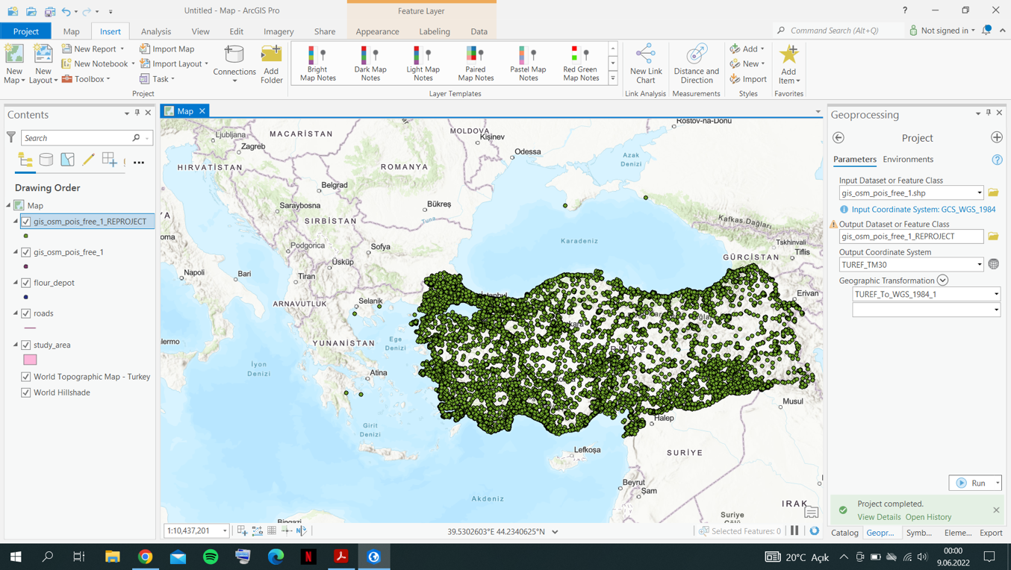

After re-projection, downloaded data clipped according to the study_area.

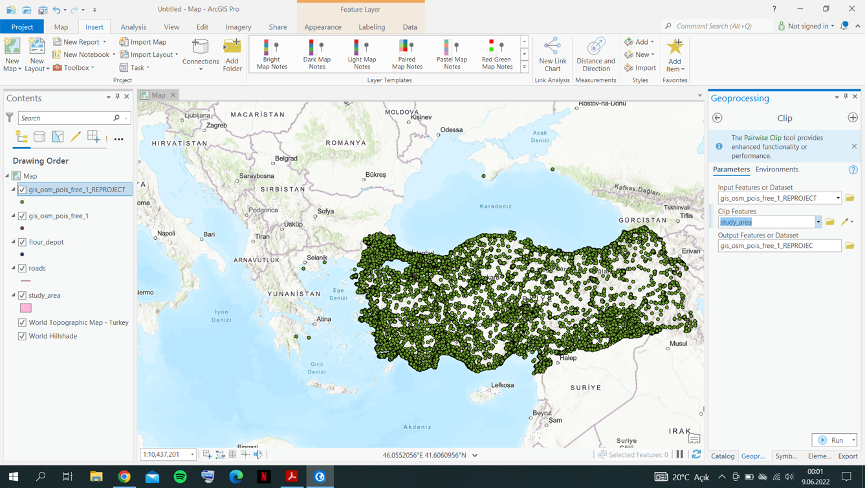

After applying clip, our downloaded osm point data looks like below.

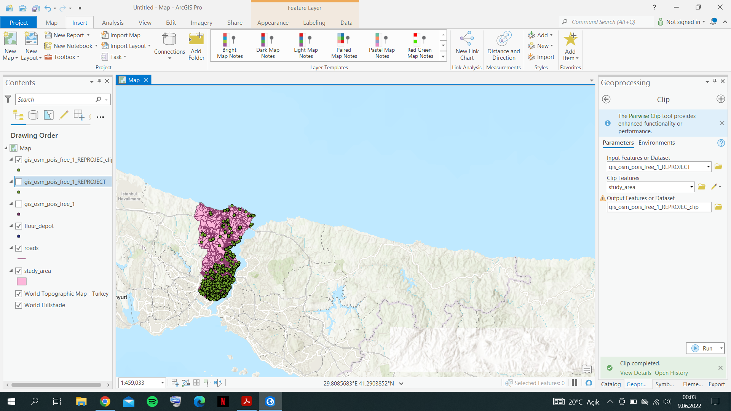

Moreover, our points contains all types of points, in other words, all kind of categories. To filter the points, Select By Attributes tool should be applied to filter only bakery, café and restaurant data. After that, since remaining data is useless in this project, they are deleted. After filtering, only 716 points are remained.

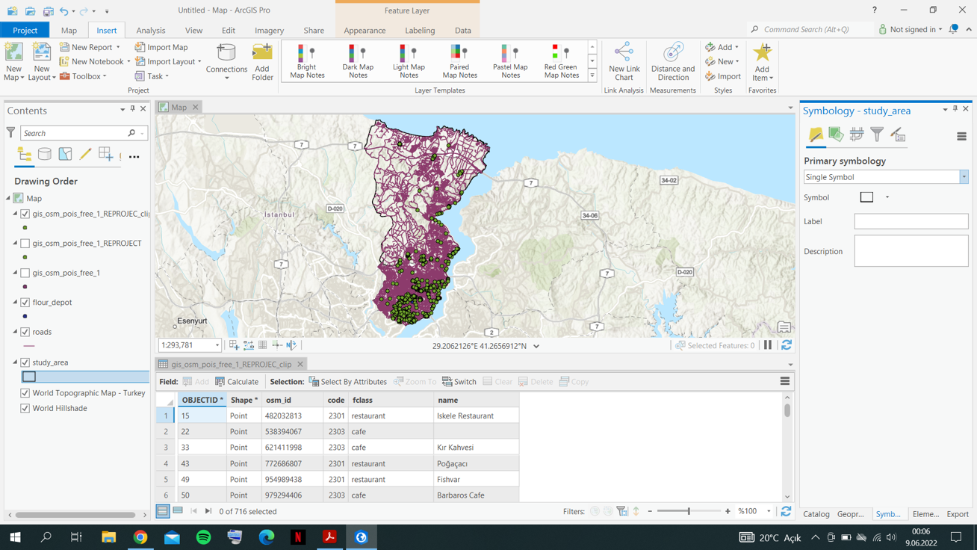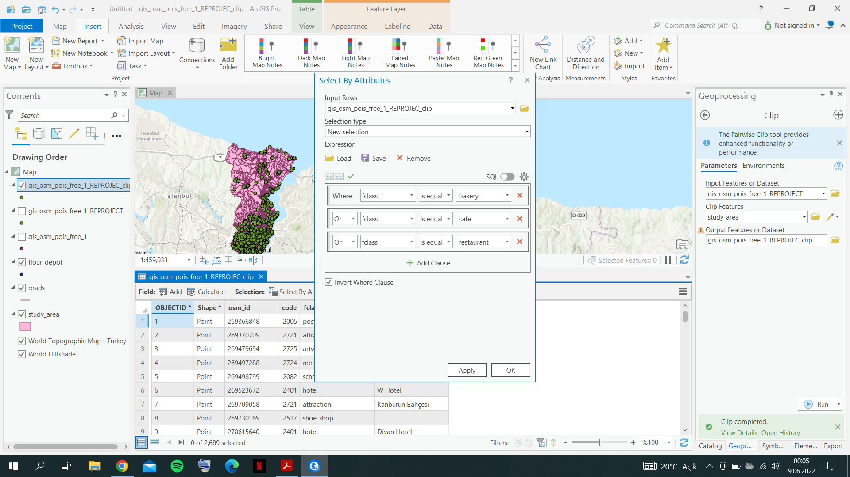

After these steps, our data is ready and can proceed on the route analysis processing steps. Before starting route analysis, it must be understood that all bakery, restaurant and café points must be visited. A route will be creating according to that information. To build network, a feature dataset must be created.

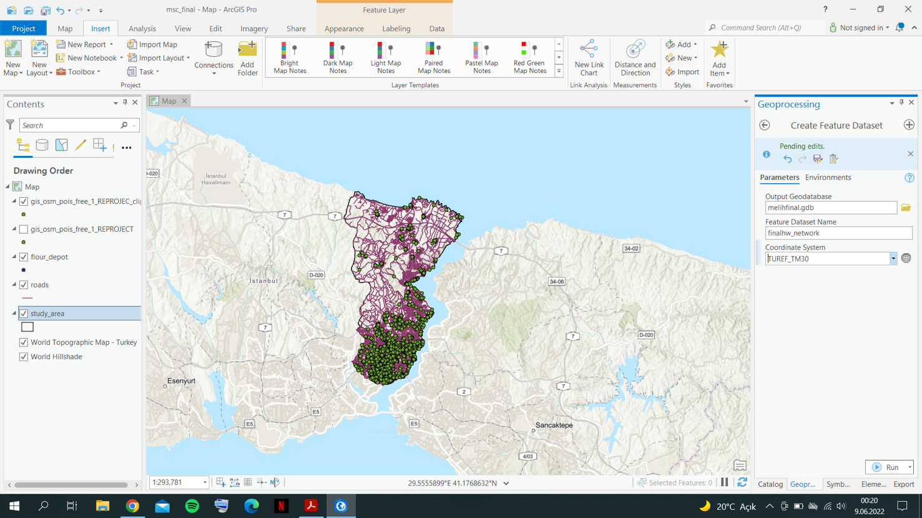

After feature dataset is created, road data which is given previously, is also needed in the feature dataset. To copy this feature to the dataset, “Feature Class to Feature Class” tool is used.

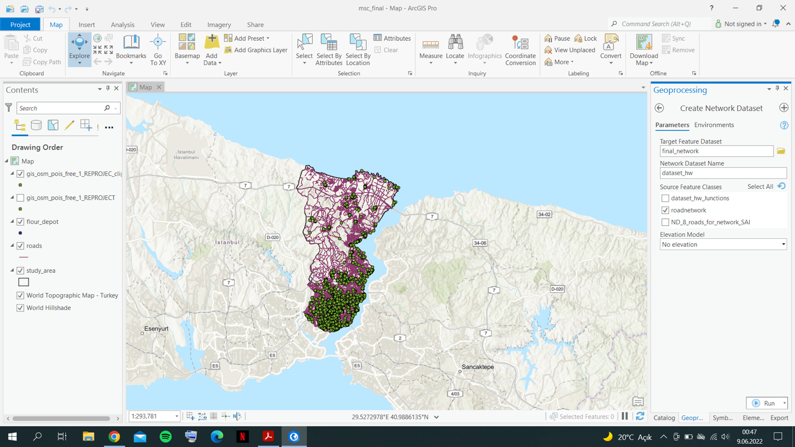

After road is exported to the dataset, a network dataset will be created. Elevation is selected as no elevation and only roads in feature dataset is selected as source feature classes.

After network dataset is created, a network is created as the final step in the network preparation step.

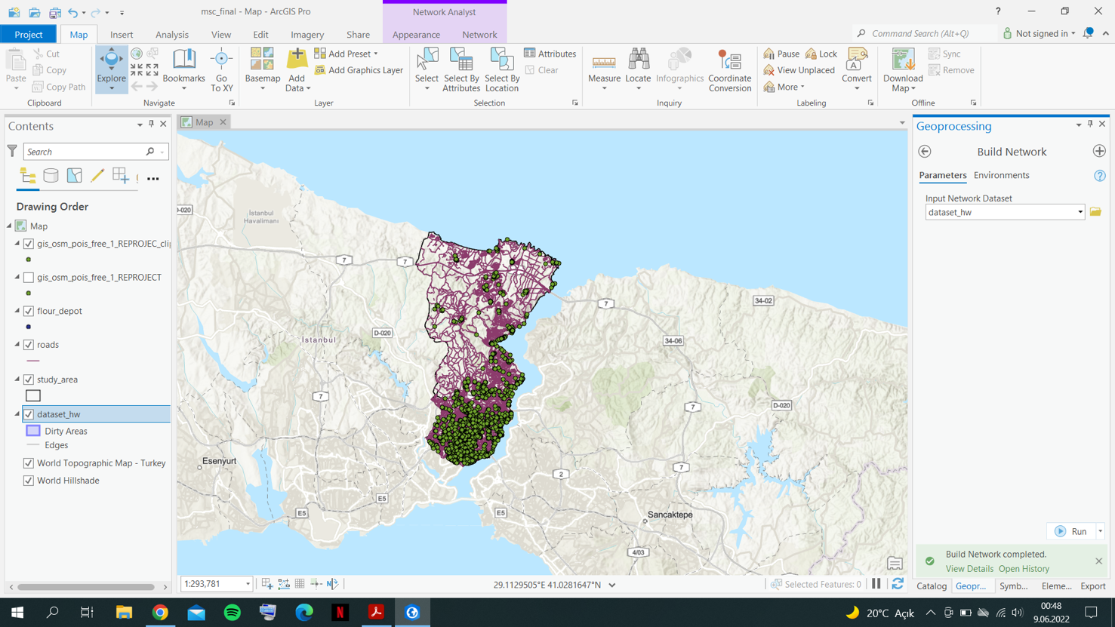

After network creation, all roads, junctions seen like below. They are all creating a one network. In other words, in bigger scale junctions and roads between the junctions can be seen below.

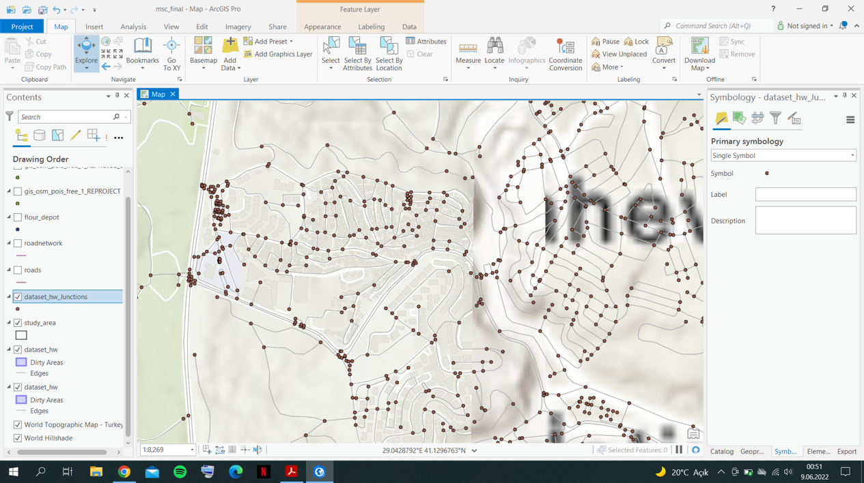

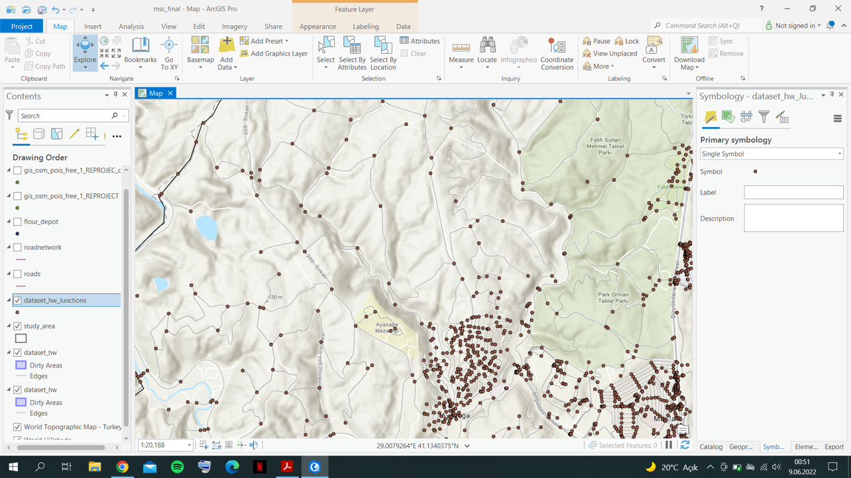

In the network dataset properties, Service-Area Index checkbox is checked and like below, kilometers is selected as units. In this window, as parameters, firstStopID is 1 and the lastStopID is 718 (n+2). This is because, we have 716 points and we to the flour depot twice in the routing (at the start and at the end).

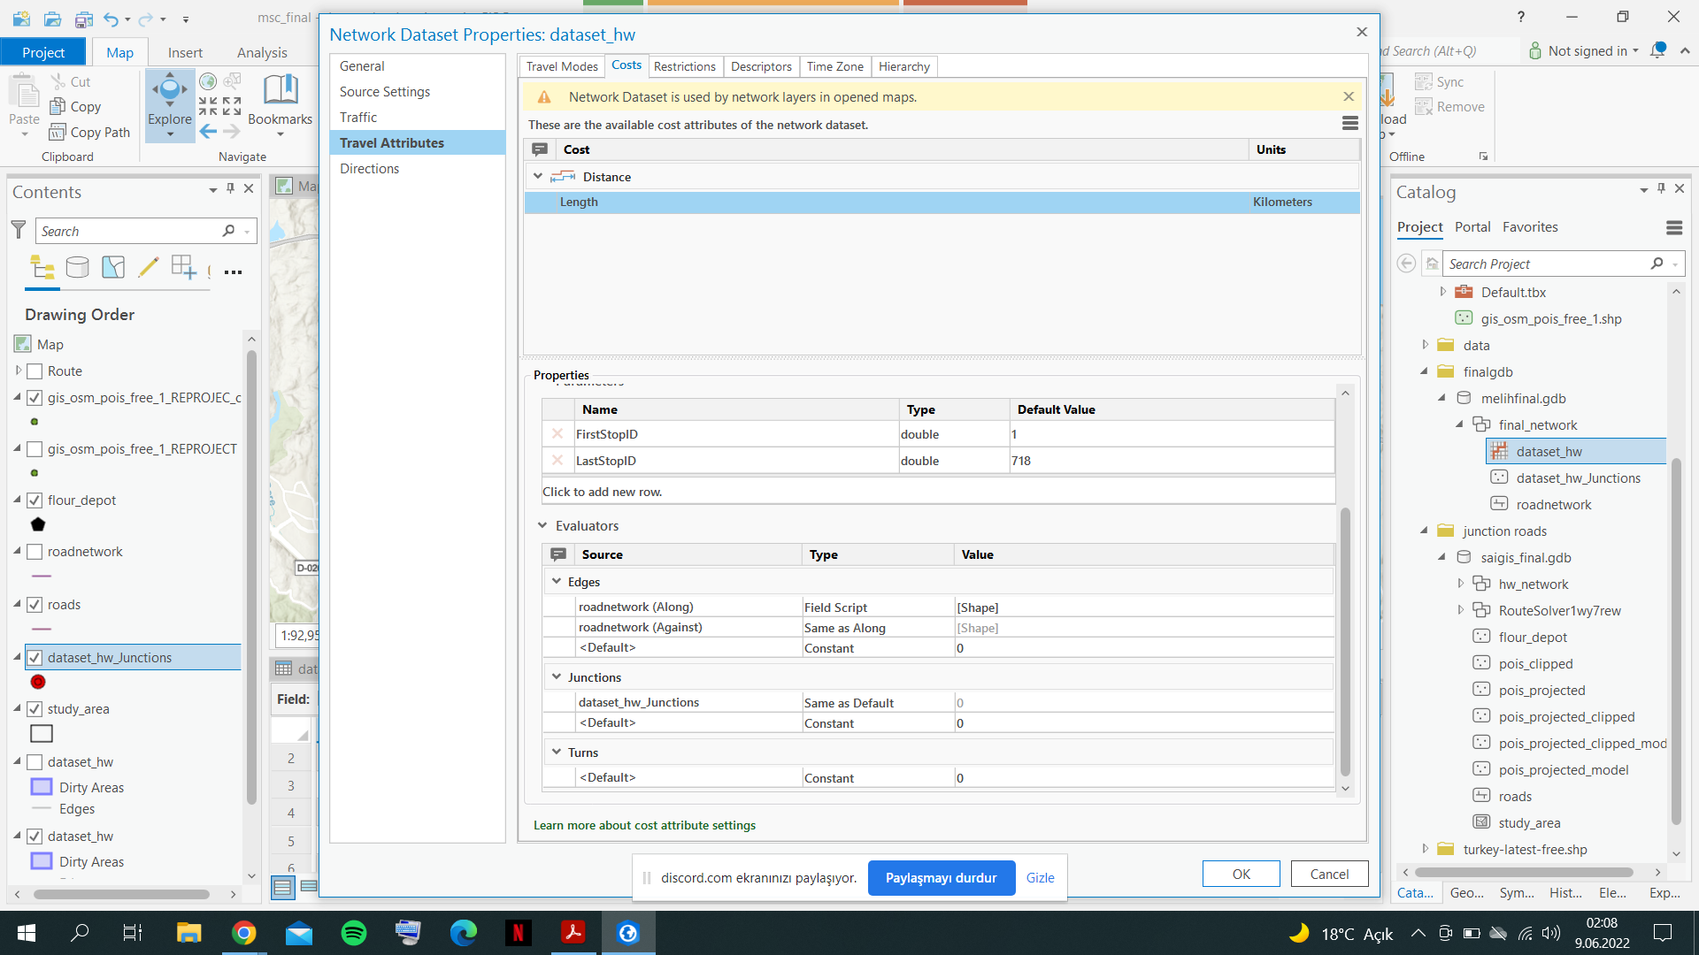

After setting the parameters, stop locations must be specified in the route section. For this purpose, a route is created by the top menu of ArcGIS. After route is created, clicked to the Import Stops-Add Location tool. Firstly, first stop is added which is first time visit to the flour depot.

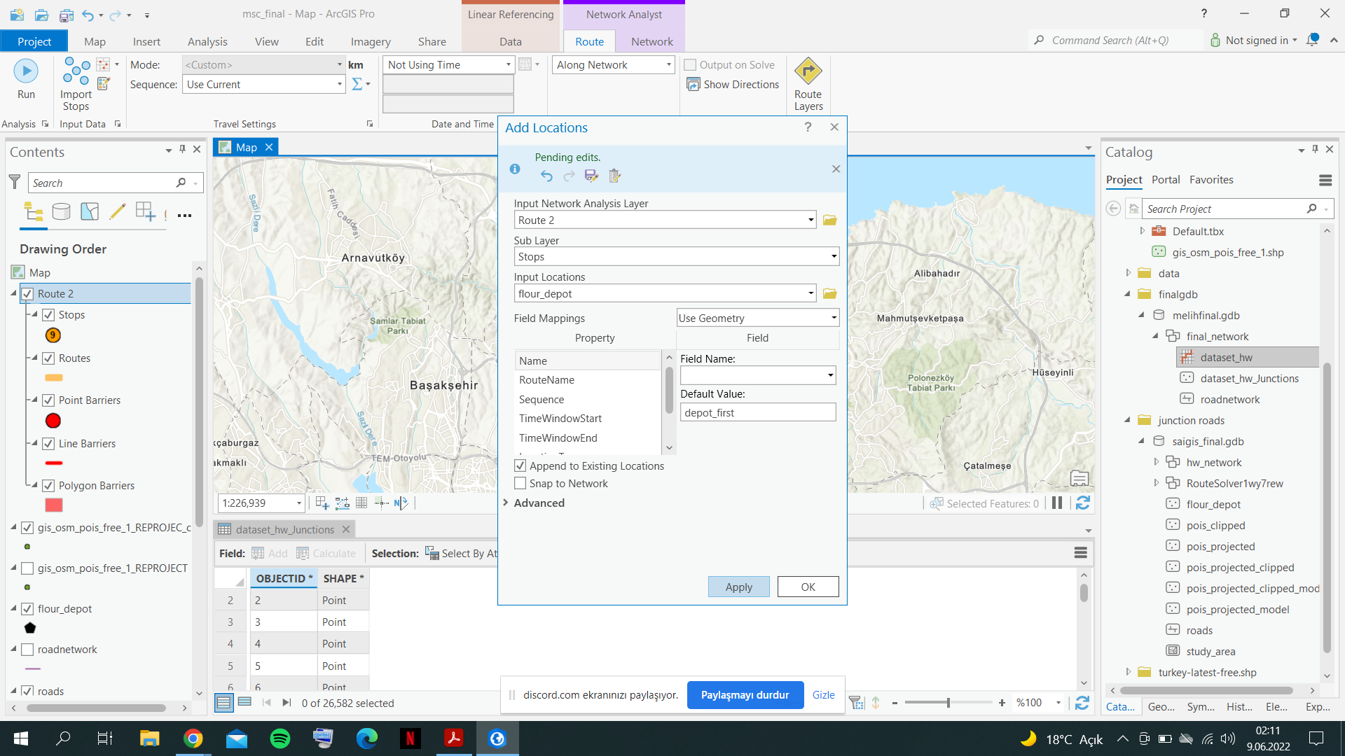

After specifying first flour depot visit, projected and clipped stop points and last time flour depot visit are added as stops, respectively.

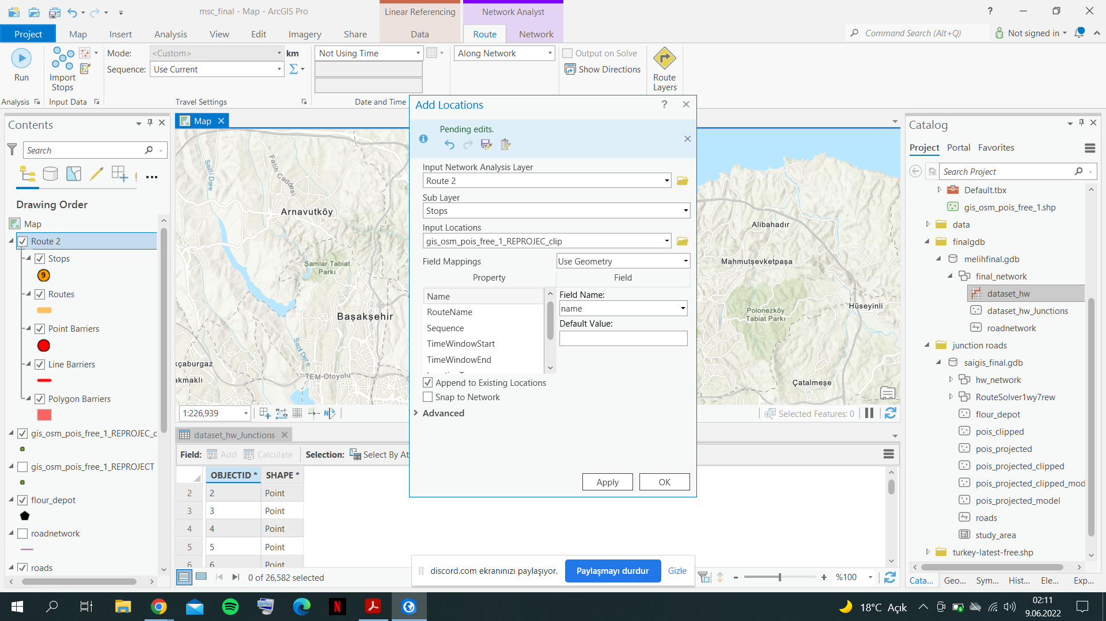 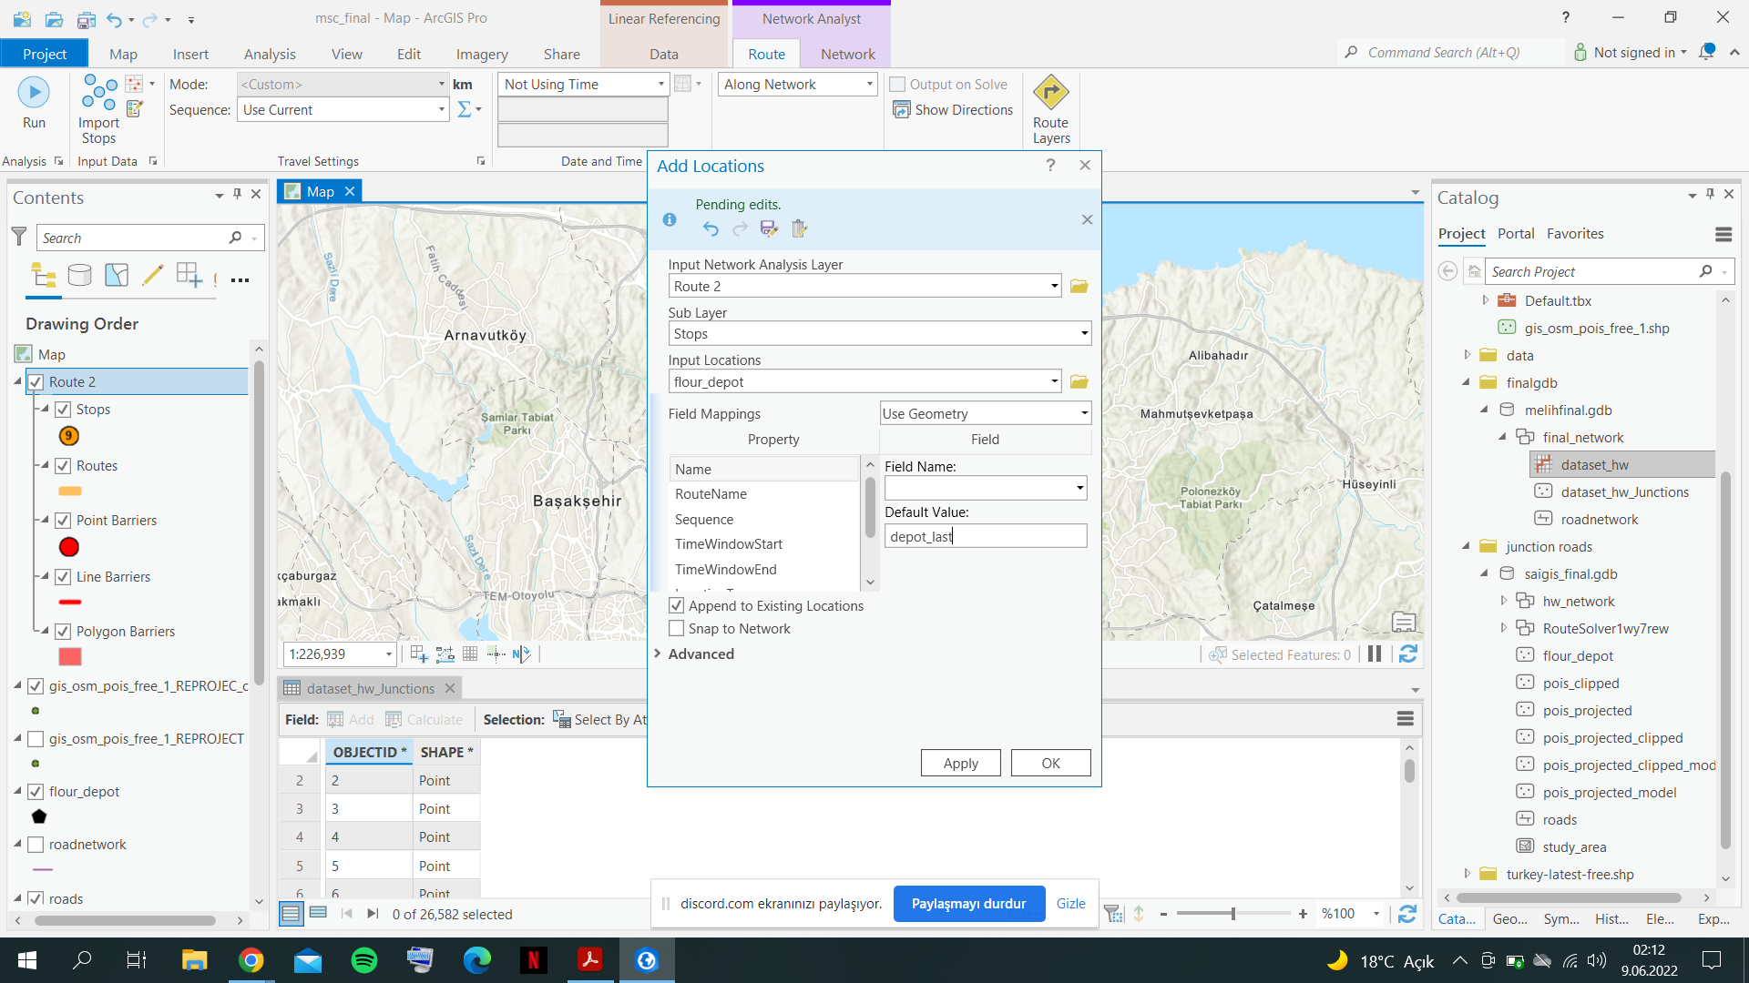

After stop locations are added, sequence is selected as Preserve First & Last Stop and executed the route analysis by Run button. Map and stops with the route can be seen as below.

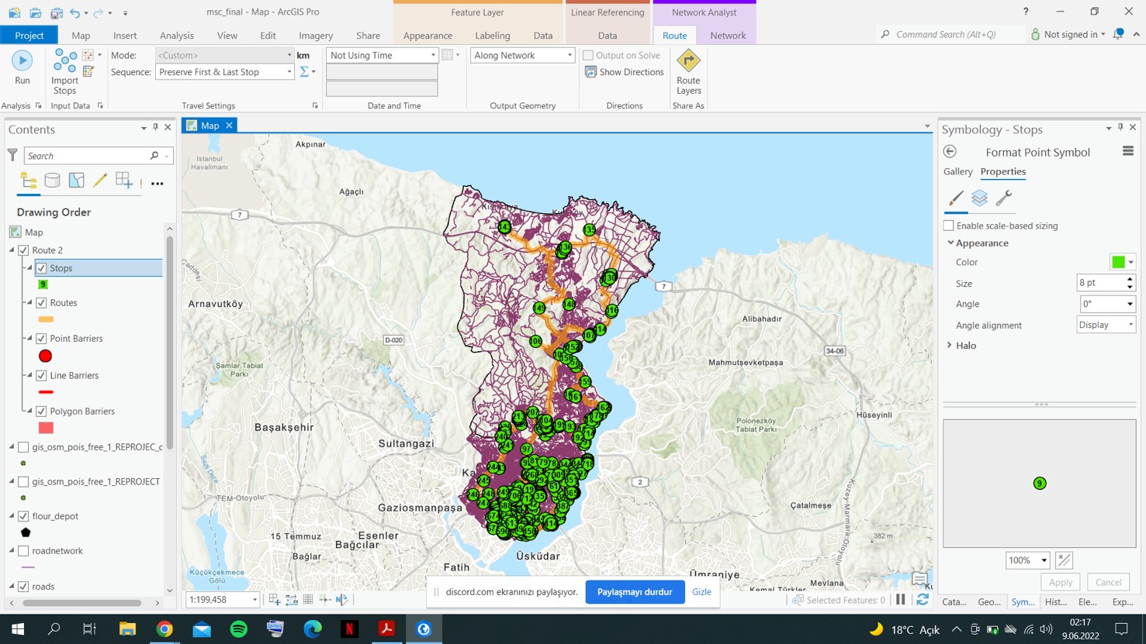

The attribute table of Route can be seen below. First and Last stops can be viewed as 1:718 since we specified them at the parameters screen of network. Name is created by the first and last stops. The total length of route is **179.4349 kilometers.**

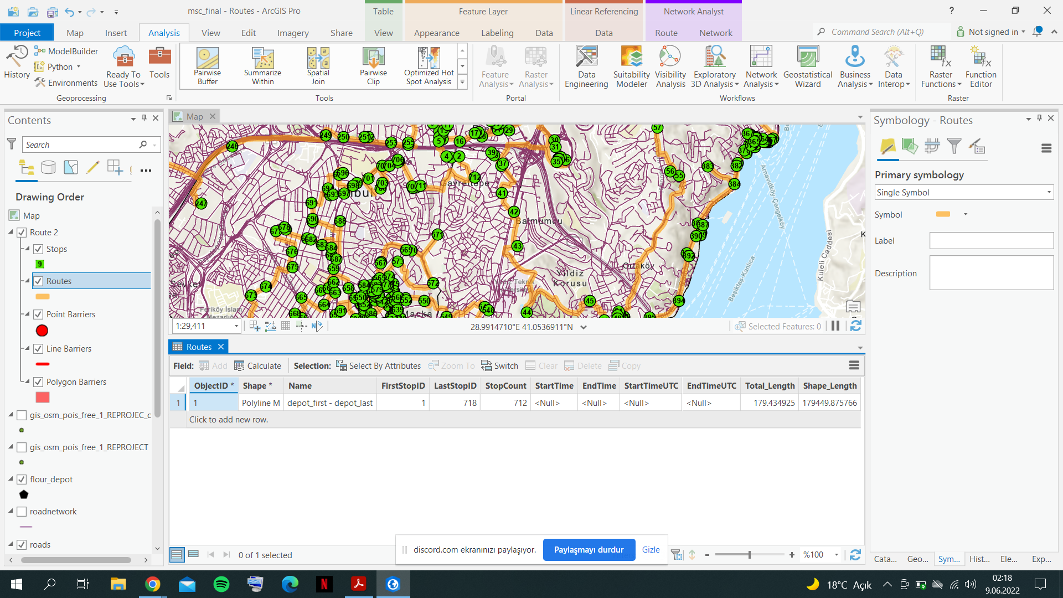

After route is created, we can proceed on the model creation. Model is automation for all the previous processes and can be created by the Model Builder tool.

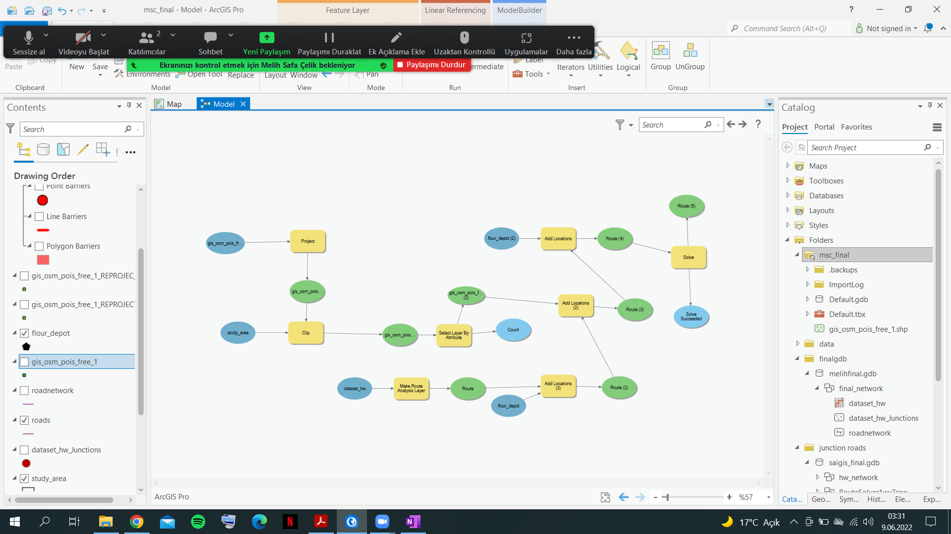

Model builder is validated successfully and runned.

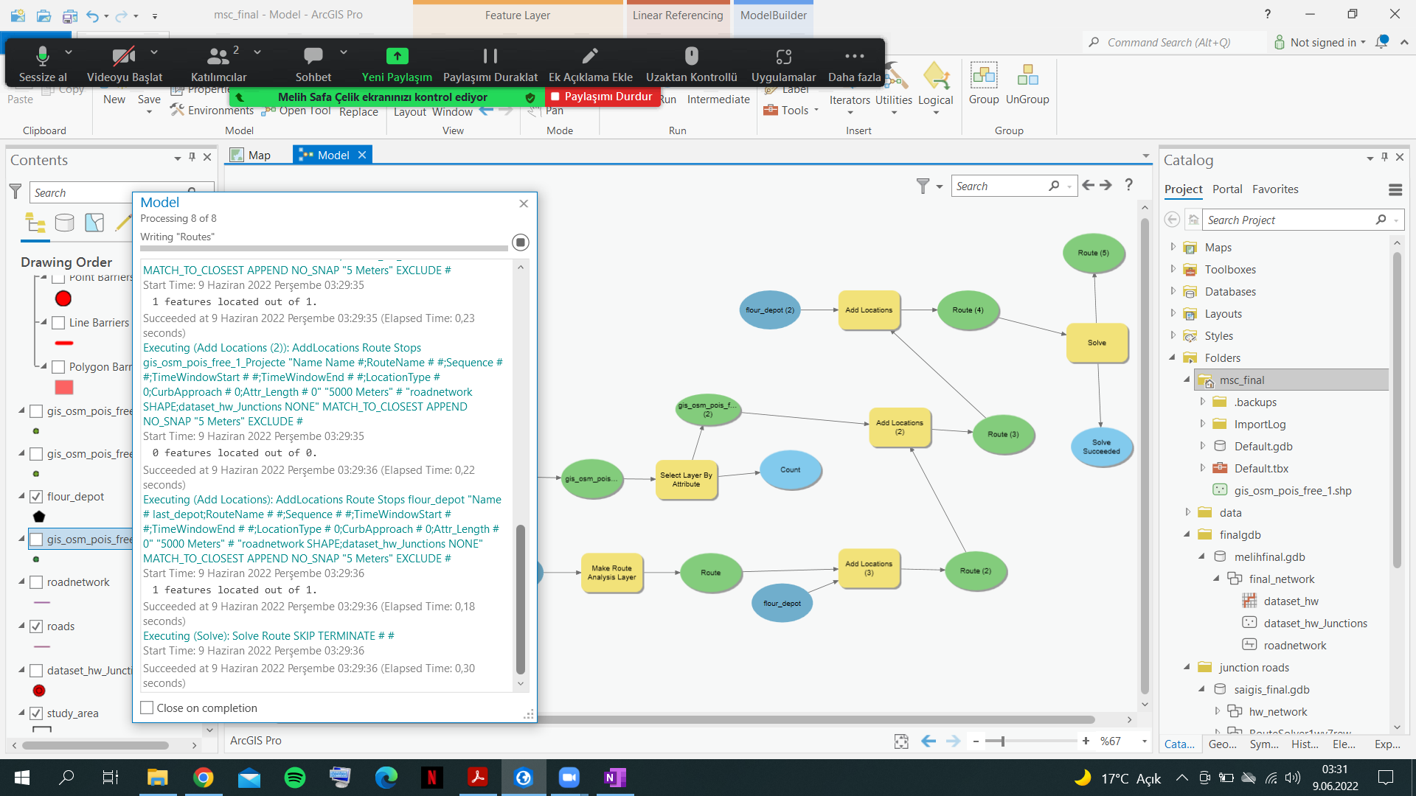

The result can be called as successful but although some of the stops are not visited and they can be seen below.

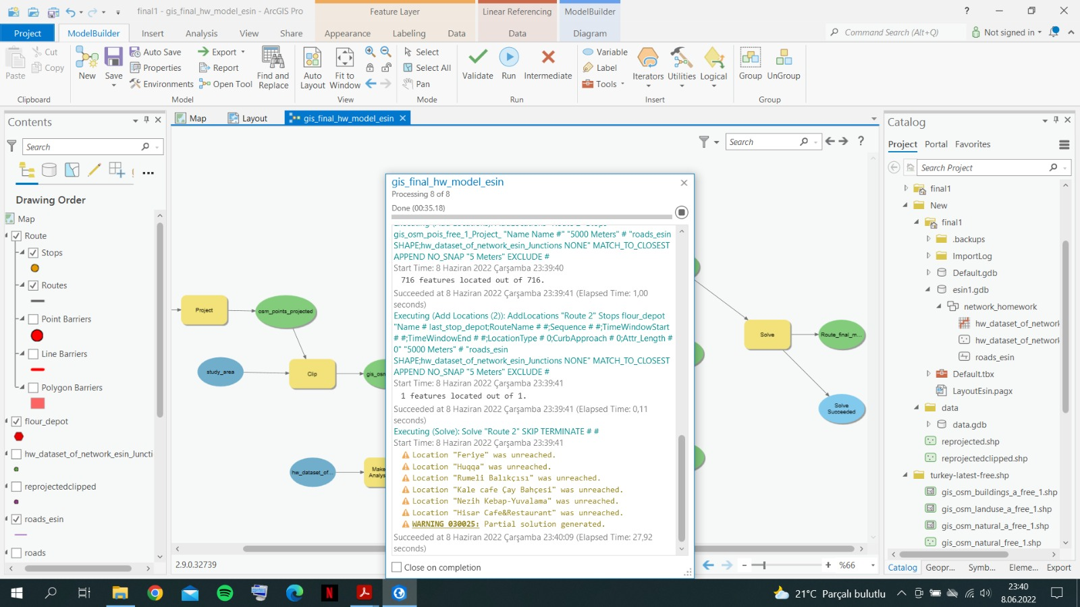

After this process, the processing steps are all done and new layout is created to present this map and this analysis. It can be found below and separately as PDF file.

